Leader board totals

Points to be noted:
- The cache period that has been implemented in Top grand totals and leaderboard totals are different. For Example, latest donation takes max 5 mins to get updated at the top grand total whereas, it takes max 15 to get updated in the leaderboard section. This might create false count to the leaderboard viewers.
- Top grand totals are brand specific and whereas, leaderboard totals are not brand specific.

Scenarios:
1. Total participants - 10

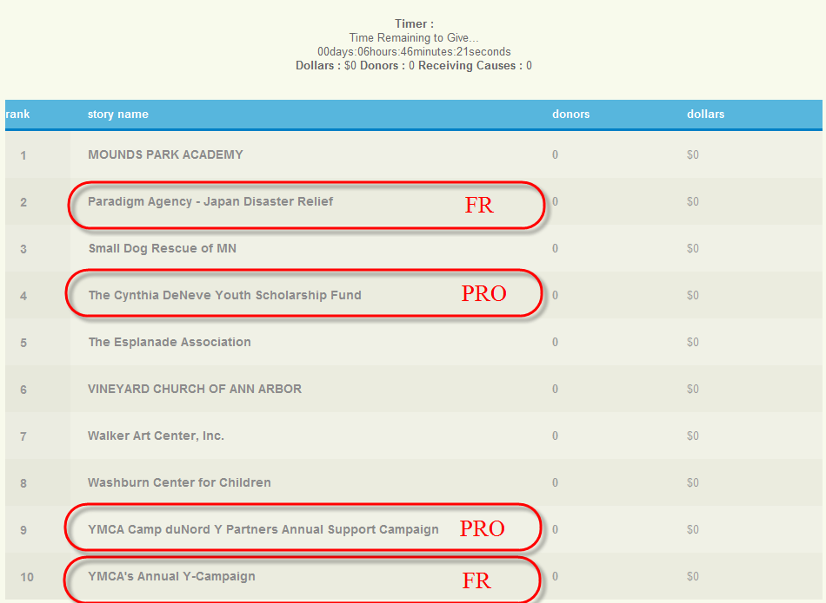

2. Donation made to FR (part of the list)

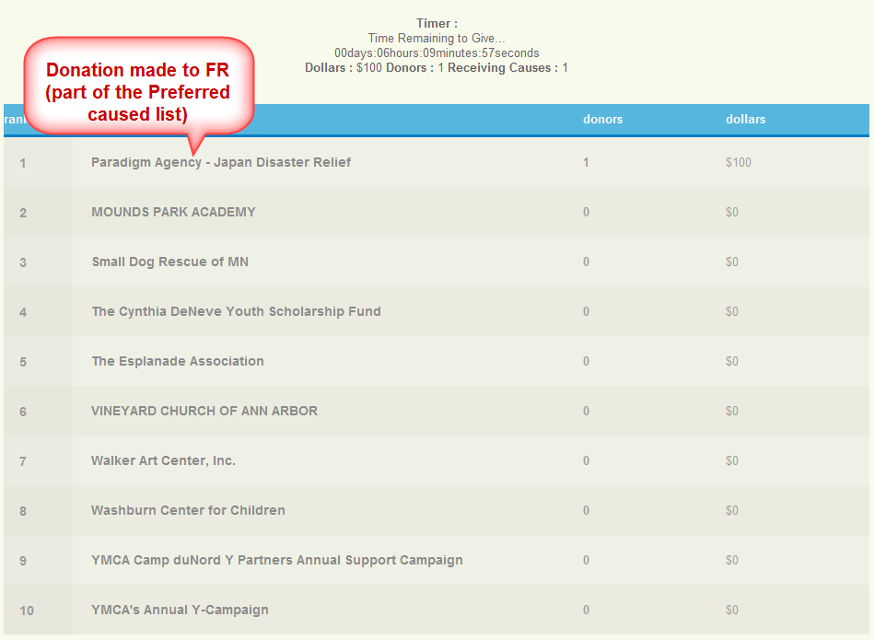

3. Donation made to Project (part of the list)

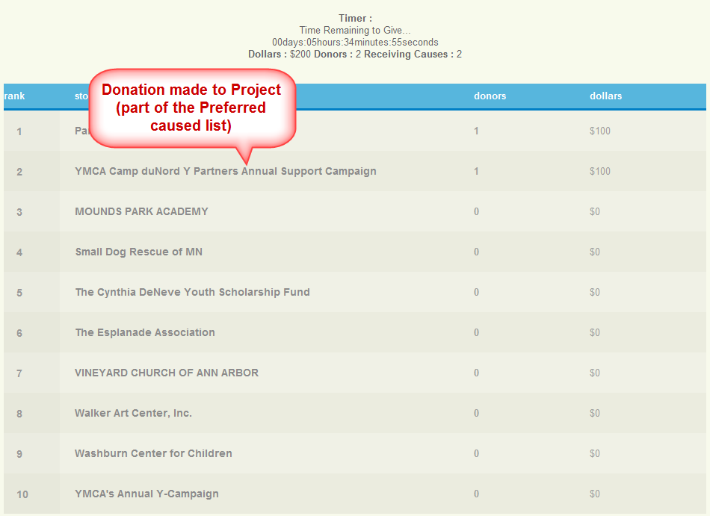

4. Donation made to Org (which is in the list and its associated FR/PRO are not part of the list)

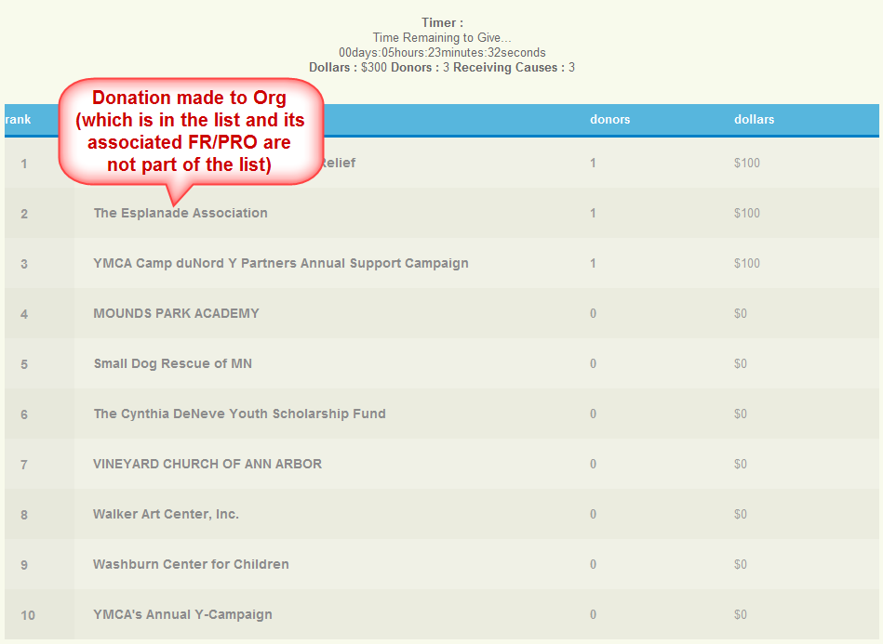

5. Donation made to FR (part of the list)

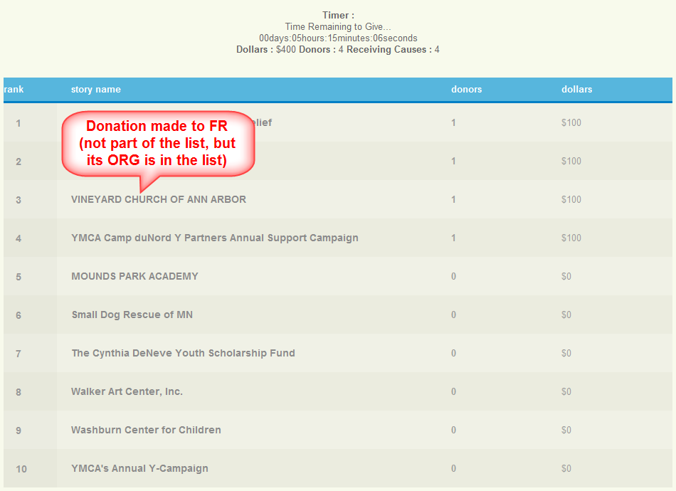

6. Donation made to Project (part of the list)

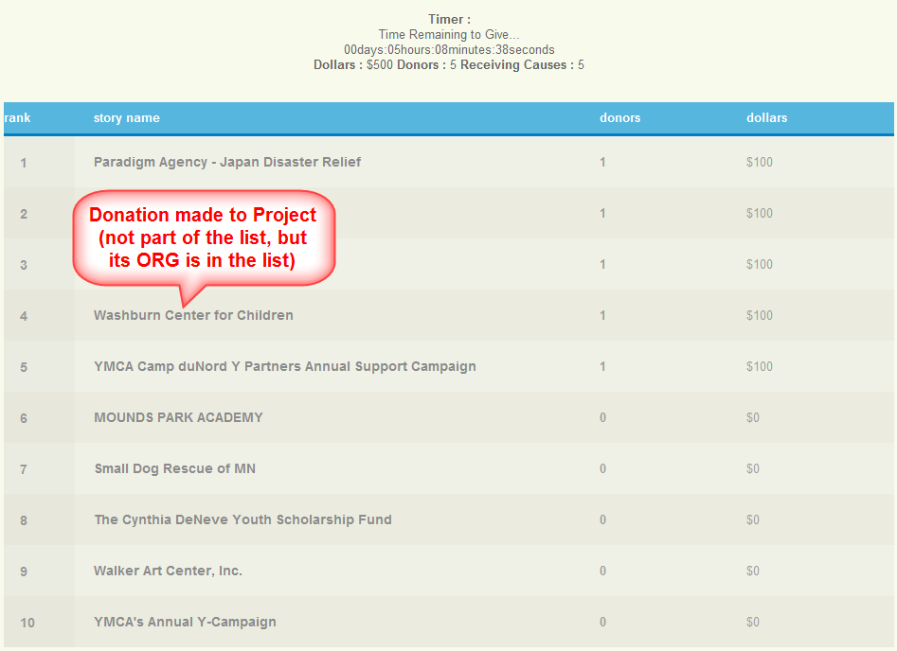

7. Donation made to ORG (part of the list), someone already donated to its associated Project

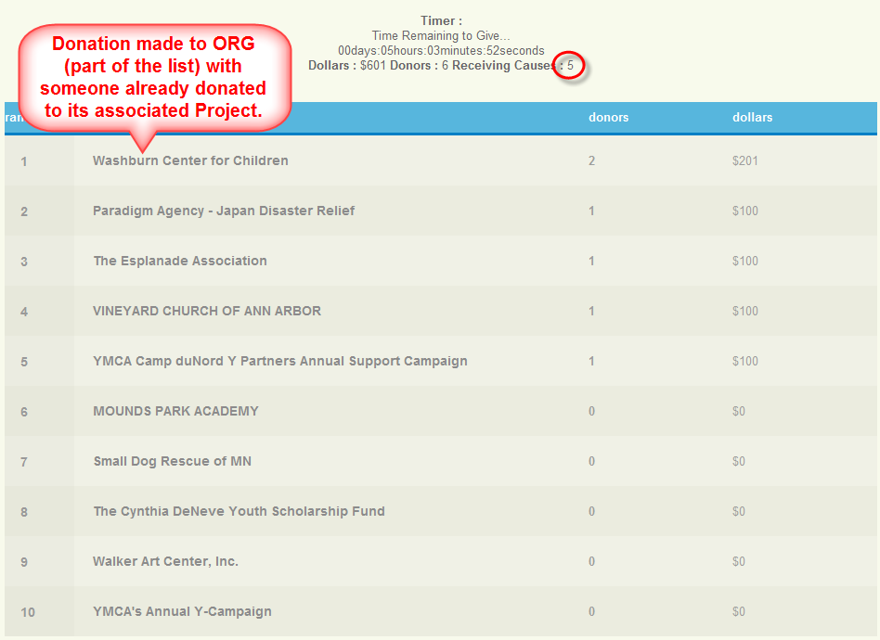

8. Refund the recent donation made

